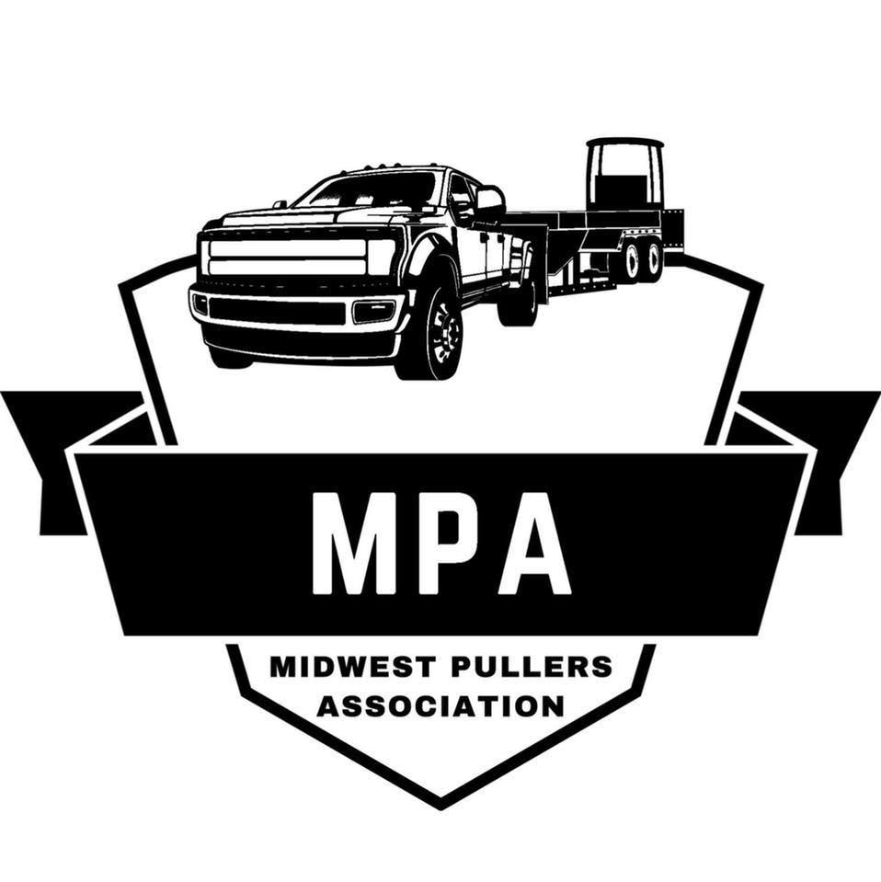
Midwest Pullers Association
One Day Event Membership Application
Please Print Clearly
Full Name: ____________________________________________________________
Mailing Address: _______________________________________________________
City/State/Zip:__________________________________________________________
Phone: _______________________ Email: __________________________________

Vehicle Information:
Class: ________________________________________________________________
Make/Model: ___________________________________________________________
Vehicle Name: __________________________________________________________
Location of Event: ___________________________ Date: ______________________

Single Event Membership Fee (non-voting & no points) is $40 payable to Midwest Pullers Association at the event plus the $30 hook fee for a total of $70.
If the participant is under 18 years of age, a Parent or Legal Guardian must sign Waiver and Release of Liability, Assumption of Risk and Indemnity Agreement.
- All participants must sign Waiver and Release of Liability, Assumption of Risk and Indemnity Form and Clutch Certification Form.
- Fees are non-refundable.

RELEASE AND WAIVER OF LIABILITY, ASSUMPTION OF RISK AND INDEMNITY AGREEMENT
IN CONSIDERATION of being permitted to compete, officiate, observe, work for, or participate in any way in the EVENT(S) or being permitted to enter for any purpose any RESTRICTED AREA (defined as the advanced staging area, burn out area, competition area, shutdown area, staging lanes, return road area, and any other area within the barriers, fences, and/or structures separating the general public from racing activities), EACH OF THE UNDERSIGNED, for himself/herself, his/her personal representatives, heirs, and next of kin.
1. Acknowledges, agrees, and represents that he/she has or will immediately upon entering any such RESTRICTED AREAS, and will continuously thereafter, inspect the RESTRICTED AREAS which he/she enters and he/she further agrees and warrants that, if at any time, he/she is in or about RESTRICTED AREAS and he/she believes anything to be unsafe or unsatisfactory in any way, he/she will immediately advise the officials of such and will leave the RESTRICTED AREAS and/or refuse to participate further in the EVENT(S).
2. HEREBY RELEASES, WAIVES, DISCHARGES AND COVENANTS NOT TO SUE the promoters, participants, racing associations, sanctioning organizations or any affiliated entities thereof, track operators, track owners, officials, vehicle owners, builders and designers, drivers, crews, rescue personnel, and persons in any RESTRICTED AREA, promoters, sponsors, equipment and parts manufacturers and suppliers, advertisers, owners and lessees of premises used to conduct the EVENT(S), premises and event inspectors, surveyors, underwriters/brokers, consultants and others who give recommendations, directions, or instructions or engage in risk evaluation or loss control activities regarding the premises or EVENT(S) and for each of them, their directors, officers, agents, and employees, all for the purposes herein referred to as “RELEASEES” FROM ALL LIABILITY TO THE UNDERSIGNED, his/her personal representatives, assigns, heirs, and next of kin, FOR ANY AND ALL LOSS OR DAMAGE, AND ANY CLAIM OR DEMANDS THEREFORE ON ACCOUNT OF INJURY TO THE PERSON OR PROPERTY OR RESULTING IN DEATH OF THE UNDERSIGNED ARISING OUT OF OR RELATED TO THE EVENT(S), WHETHER CAUSED BY NEGLIGENCE OF ANY RELEASEE(S) OR OTHERWISE.
3. HEREBY AGREES TO INDEMNIFY AND SAVE AND HOLD HARMLESS the RELEASEES and each of them FROM ANY LOSS, LIABILITY, DAMAGE, FEES OR COSTS they may incur arising out of or related IN ANY MANNER TO MY ATTENDANCE AT OR PARTICIPATION IN THE EVENT(S), AND WHETHER CAUSED BY THE NEGLIGENCE OF ANY RELEASEE(S) OR OTHERWISE.
4. HEREBY ASSUMES FULL RESPONSIBILITY FOR ANY RISK OF BODILY INJURY, DEATH OR PROPERTY DAMAGE arising out of or related to the EVENT(S) whether caused by the NEGLIGENCE OF ANY RELEASEE(S) OR OTHERWISE.
5. HEREBY acknowledges that THE ACTIVITIES OF THE EVENT(S) ARE DANGEROUS and involve the risk of serious injury and/or death and/or property damage. Each of THE UNDERSIGNED also expressly acknowledges that INJURIES RECEIVED MAY BE COMPOUNDED OR INCREASED BY NEGLIGENT RESCUE OPERATIONS OR PROCEDURES OF THE RELEASEES.
6. HEREBY agrees that this Release and Waiver of Liability, Assumption of Risk and Indemnity Agreement extends to all acts of negligence by the RELEASEES, INCLUDING NEGLIGENT RESCUE OPERATIONS and is intended to be as broad and inclusive as is permitted by the laws of the Province or State in which the EVENT(S) is/are conducted and that if any portion thereof is held invalid, it is agreed that the balance shall, notwithstanding, continue in full legal force and effect.
I HAVE READ THIS RELEASE AND WAIVER OF LIABILITY, ASSUMPTION OF RISK AND INDEMNITY AGREEMENT, FULLY UNDERSTAND ITS TERMS, UNDERSTAND THAT I HAVE GIVEN UP SUBSTANTIAL RIGHTS BY SIGNING IT, AND HAVE SIGNED IT FREELY AND VOLUNTARILY WITHOUT ANY INDUCEMENT, ASSURANCE OR GUARANTEE BEING MADE TO ME AND INTEND MY SIGNATURE TO BE A COMPLETE AND UNCONDITIONAL RELEASE OF ALL LIABILITY TO THE GREATEST EXTENT ALLOWED BY LAW.

_____________________________________________
Participant Name (Print)

______________________________________________ ______________________________
Signature Date

2026 Clutch Certification

Please Print Clearly

The undersigned guarantees that the competition vehicle described above is currently equipped, and will be continually equipped, with all clutch assembly, flywheel, bell-housing components and required shields that are equal to, or exceed, the minimum safety requirements as defined in the 2026 Midwest Pullers Association rules, while participating in ay Midwest Pullers Association sanctioned event.

The undersigned understands that this guarantee of compliance with all 2026 Midwest Pullers Association rules for all clutch assembly, flywheel, bell-housing components and required shields expires on December 31st, 2026.

___________________________________________________ _______________
Signature of Owner or Driver Date

