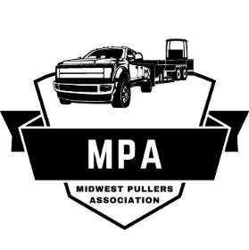
Midwest Pullers Association
Sponsorship Form
Midwest Pullers Association has 4 levels of sponsorship. Each level comes with its own rewards, see below for the breakdown of each level.
Copper: $100
Name on a 12” X 18” double sided yard sign displayed at every pull.

Bronze: $250
Name on a 18” X 24” double sided yard sign and placed in SMALL font on a shared banner displayed at every pull.

Silver: $500
Name on a 24” X 24” double sided yard sign and placed in MEDIUM font on a shared banner displayed at every pull.
2 pit passes to your choice of event.
Featured in sponsorship spotlight on Midwest Pullers Association-Official Facebook page.

Gold: $1000
Name on a 24” X 30” double sided yard sign and placed in LARGE font on a shared banner displayed at every pull.
4 pit passes to your choice of event.
Featured in sponsorship spotlight on Midwest Pullers Association-Official Facebook page.
Logo on MPA apparel.

All sponsors will be announced at every pull during the event and to present services or products for display during events.
Midwest Pullers Association participates in county fairs, town celebrations, and various other truck and tractor pull events throughout central Iowa each summer. We are a grassroots pulling association putting on great shows for the youngest to oldest of fans. If you are interested in becoming a sponsor, please fill out the information on page 2 and send to the address at the bottom of the page.

Sponsoring Business Name: ______________________________________________________
Sponsorship Level: _____________________________________________________________
Address: _____________________________________________________________________
Phone Number: _______________________________________________________________
Email Address: ________________________________________________________________
Website: _____________________________________________________________________
Facebook Page (Y/N) If yes, Name: ________________________________________________
In one paragraph please describe your business (this will be used in advertising at events and on Facebook). _________________________________________________________________
__________________________________________________________________________________________________________________________________________________________
**Please email a high-definition logo to**: midwestpullersassociation@gmail.com
PLEASE RETURN FORMS and CHECKS PAYABLE TO
MIDWEST PULLERS ASSOCIATION
BY APRIL 1, 2026

Mailing Address: Midwest Pullers Association
Attn: Holly Gulling
560 NW 2nd ST
Earlham, IA 50072
For any questions, please Contact Mike Bower 641-373-7517
Thank You For Your Support!

